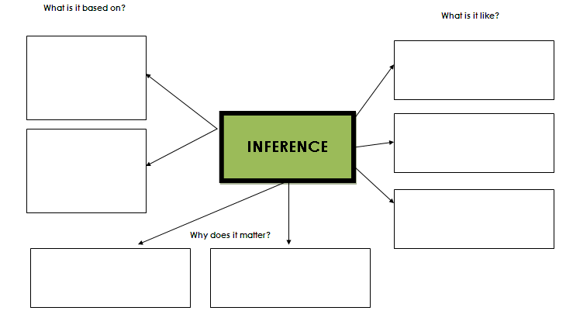

Prior knowledge, experience

Helps you figure out the correct answer

Helps you understand your reading

Evidence, textual evidence, facts, proof

A guess

Estimation

Hypothesis